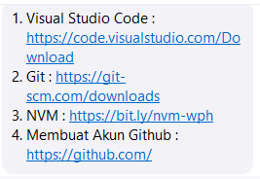

{
"workbench.colorTheme": "Dracula Theme",
"workbench.iconTheme": "vscode-icons",
"editor.formatOnSave": true,
"editor.defaultFormatter": "esbenp.prettier-vscode",
"[javascript]": {
"editor.defaultFormatter": "esbenp.prettier-vscode"
},
"[typescript]": {
"editor.defaultFormatter": "esbenp.prettier-vscode"
},
"[json]": {
"editor.defaultFormatter": "esbenp.prettier-vscode"
},
"[html]": {
"editor.defaultFormatter": "esbenp.prettier-vscode"
},
"[css]": {
"editor.defaultFormatter": "esbenp.prettier-vscode"
},
"[javascriptreact]": {
"editor.defaultFormatter": "esbenp.prettier-vscode"
},
"files.autoSave": "afterDelay",
"terminal.integrated.defaultProfile.windows": "Git Bash",
"terminal.integrated.profiles.windows": {
"Git Bash": {
"path": "C:\\Program Files\\Git\\bin\\bash.exe"
}
}
}

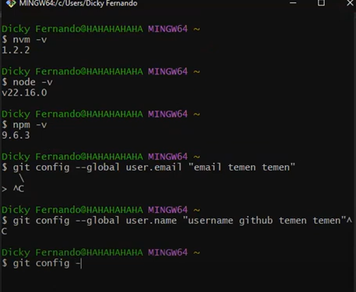

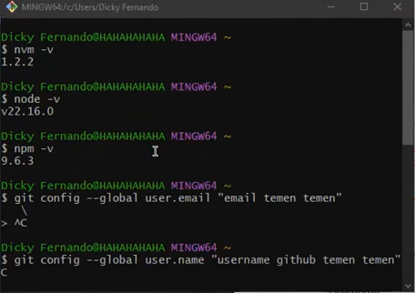

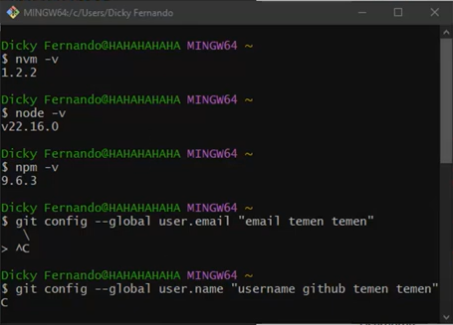

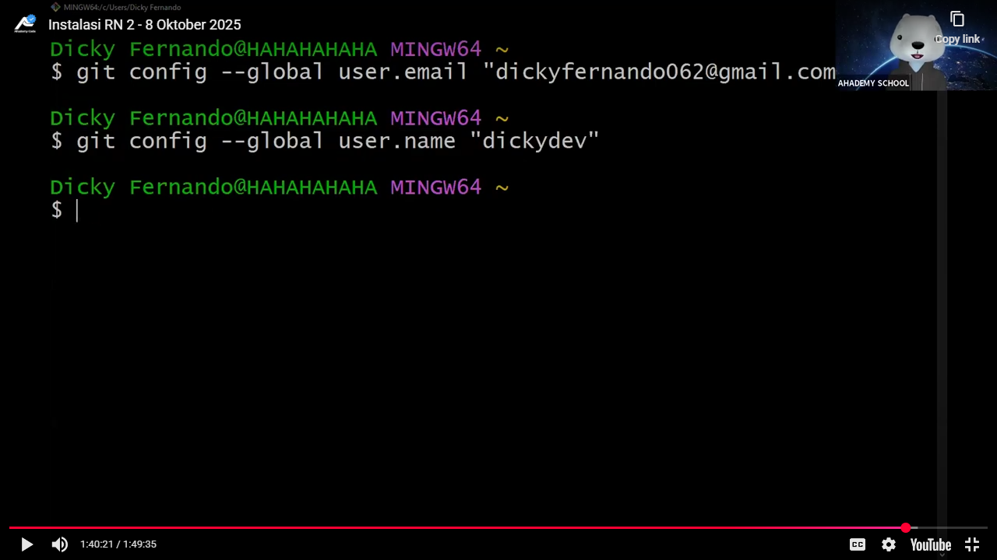

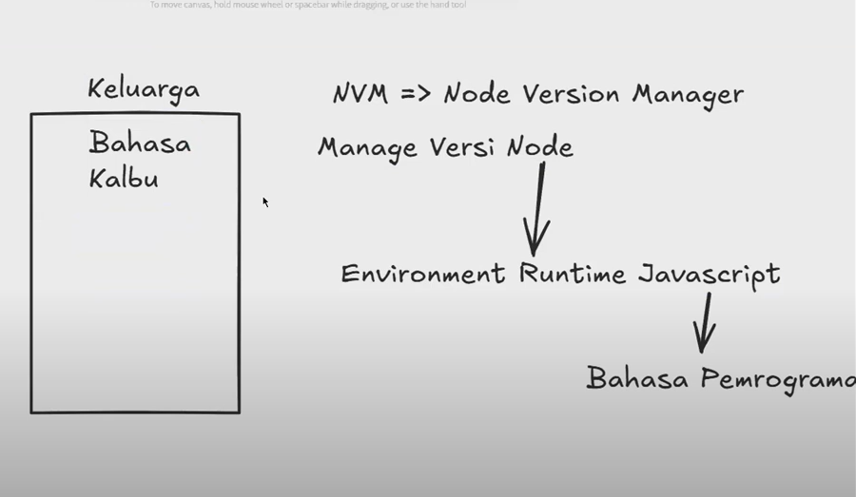
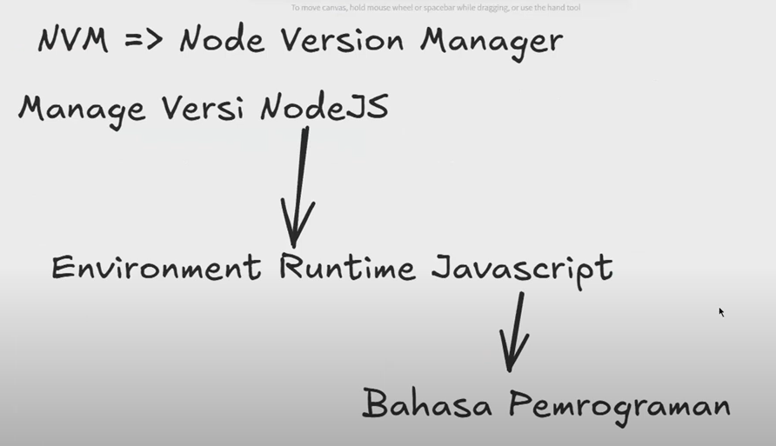

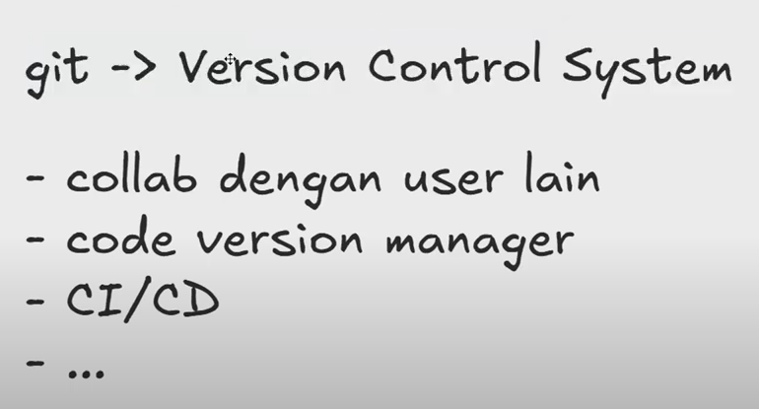

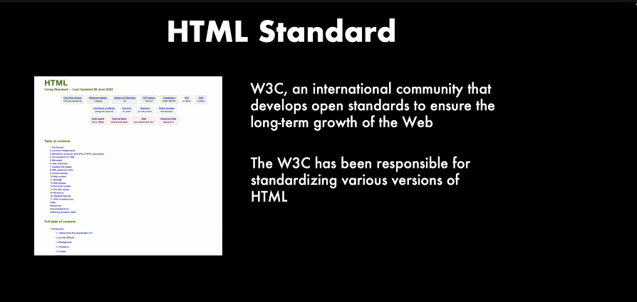

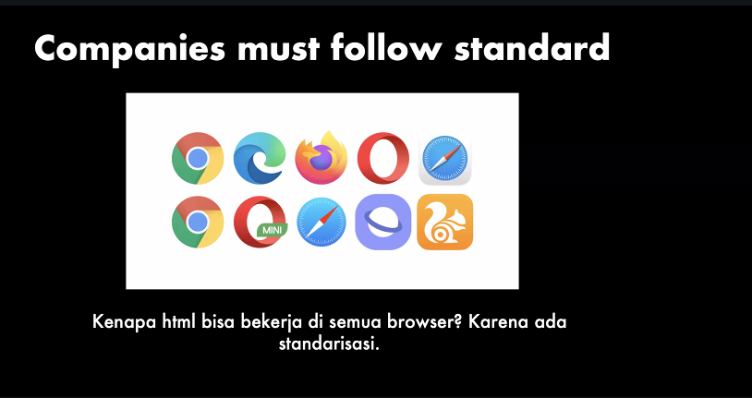

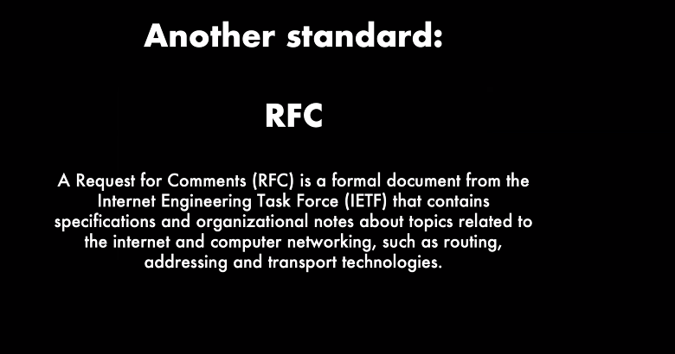

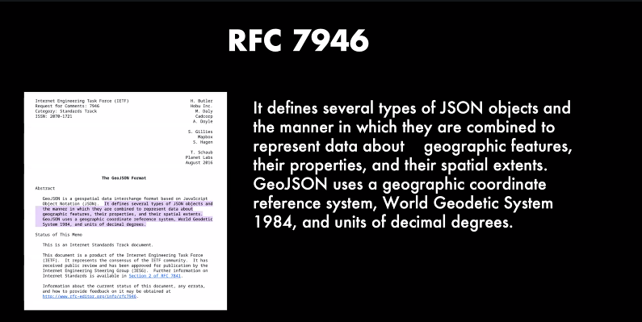
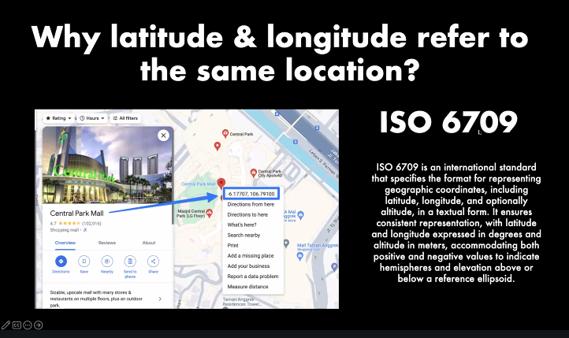

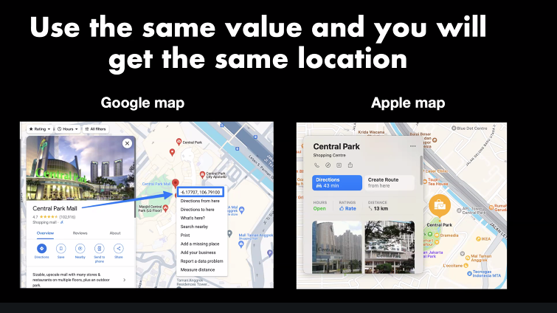
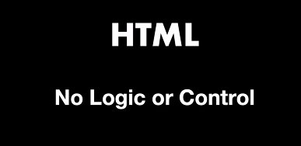
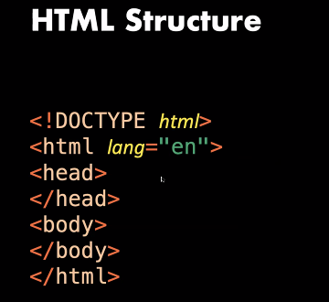
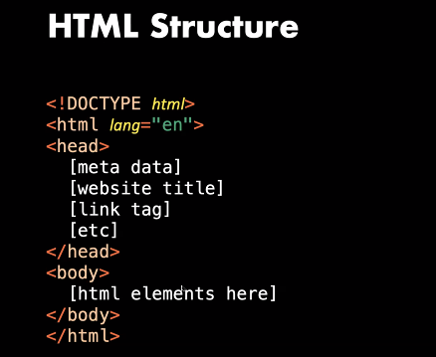

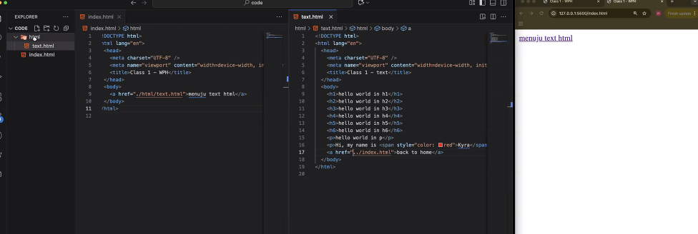

Hari 2
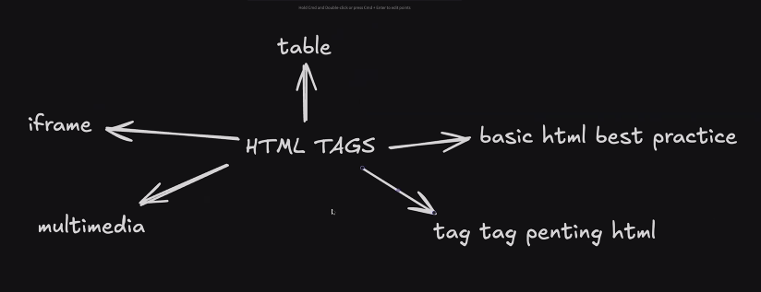

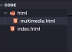

<!DOCTYPE html>
<html lang="en">
<head>
<meta charset="UTF-8" />
<meta name="viewport" content="width=device-width, initial-scale=1.0" />
<title>Class 2</title>
</head>
<body>
<a href="./html/multimedia.html">menuju multimedia html</a>
</body>
</html>

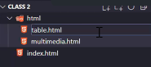
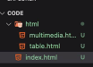

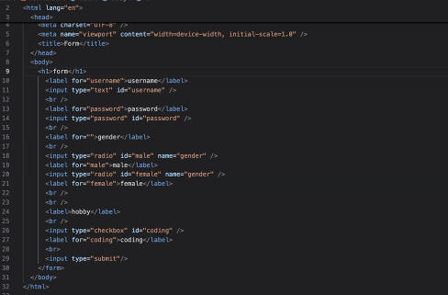
Kak bikin note apa shortcutnya, maap lupa
ctrl/cmd + /

